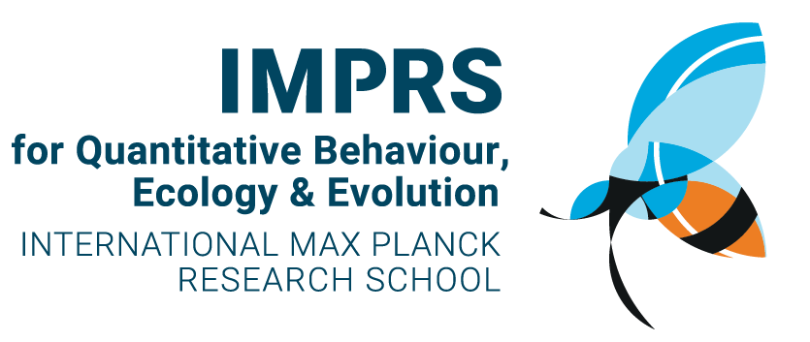
Table 1: Check List of the structured IMPRS-QBEE program, credits are based on recognised ECTS. Maximum of 30 ECTS credits can be awarded by the IMPRS.

IMPRS-QBEE Curriculum | Start of doctorate: |  | Own check point:
Thesis Advisory Committee | Credit points (CP) |  | (date)
1st TAC meeting (ca. 6 months + draft proposal) |  | 0
2nd TAC meeting (ca.12 month +final proposal) |  | 0
3rd + 4th TAC meeting(s), once per year, every year |  | 0
First author publications in international journals |  | 0 | when part of the doctoral thesis
Non-first author publications in international journals |  | 0 | when part of the doctoral thesis
Additional Curricular elements
Introduction week mid-Oct each year |  | 3
Statistics introduction+ Animal ethics in DE + workshop introduction to PhD (social) + GSP |  |  | Depending on effort/ time invested
Transferable skills |  | 4
Workshops: scientific writing, presenting, time management, grant writing, experimental design, teaching,…  research ethics, career development | According  to ECTS  2-day course is worth 1 CP |  | Depending on effort / time invested
Specific research skills |  | 4
Lab courses, summer schools, statistics, first-aid course (in field), data management, Matlab, animal care (FELASA) and/or internships…
Outreach activities |  | 4
Presentations at international conferences
Public outreach (radio, teaching, newspaper, public talk, …) Newsletter from IMPRS by Doc student
(incl. Alumni interviews)
Mentoring a MSc or BSc student
Other scientific activities  Retreat *2 (inlc. 1*organization) |  | ca.5
Active participation in PhDnet, scientific events, active participation in scientific societies, teaching, student rep for IMPRS…
Hosting speakers at GCS (institute symposium)
TOTAL | minimum | 20

